**CSE1100 – Programming Concepts with Python**

**Programming Concepts Lab Report**

**Fall 2021**

*By*

Cael Shoop

*Computer Science, B.S.*

*cshoop2018@my.fit.edu*

Friday, August 27, 2021

Lab #1

Teaching Instructor:

Stefan Joe-Yen, Ph.D.

# 1. Problem Statement

The problem was ‘Hello, world!’ programs are overused. It was necessary to make a variant to use while writing these python programs.

# 2. Requirements

1. The software shall display a specific welcome message specific to the class.
   1. The message is: ‘Hello all! This is my first Python program for CSE1100.’

# 3. Software Construction (Annotated Python Code)

**Lab 1**

'''Lab 1 Problem 1 program written by Cael Shoop for CSE1100.'''

def main():

# Prints the predefined statement

print('Hello all! This is my first Python program for CSE1100.')

if __name__ == '__main__':

main()

# 4. Software Testing

**

# 5. Self-Reflection

I did not learn anything or encounter any challenges.

# 1. Problem Statement

The problem was the need for a program that caters to a user’s specific identity and preferences.

# 2. Requirements

1. The software shall ask the user for multiple inputs and reuse the entered information in a single output.

2.1 The first input is the user’s name. The second input is the user’s favorite food.

2.2 The output is ‘Great to meet you, <<name>>! <<food>> sounds tasty!’

# 3. Software Construction (Annotated Python Code)

**Lab 2**

'''Lab 1 Problem 2 program written by Cael Shoop for CSE1100.'''

def main():

# Takes user's name as input in 'name'

name = input('Hello! What is your name?\n')

# Takes user's favorite food and stores it as input in 'food'

food = input('What is your favorite food?\n')

# Combines script with entered information during print statement

print('Great to meet you, ' + name + '! ' + food + ' sounds tasty!')

if __name__ == '__main__':

main()

# 4. Software Testing

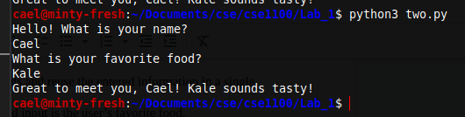

# 5. Self-Reflection

I previously have never used input with the prompt contained within the function parameters, so I got to try that out for the first time today. I ran into no challenges.